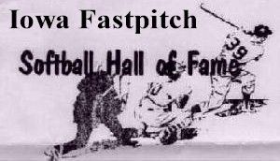
Iowa Men’s Fastpitch HOF’er
March 15, 2026

Voting for New Membership Is Now Open
Current resumes on file include: Jack Arendt, Gordy Baker, Jim O’Hern, Dave Donahue, Russ Hutchinson, Greg Mara, Brian Nelson, Scott O’Brien, JR Ogden, Matt Palazzo, Scott Smith, Zack Smith, Bob Splinter, Larry Svoboda, Brad Wedeking, and Charles Stufflebeem Sr.
Our HOF electronic election is now open through March 31st.
This Email plus a Text Message was sent to you with this voting link:
https://forms.gle/Hmt4Q1e4hqUKs4XAA
It is recommended/easier that you use a computer to go to our website to review each candidate’s full resume and a single page summary along with a preparation scorecard (print scorecard and mark it ahead of time to make actual voting easier for when you vote). You should review each and every candidate’s resume and/or summary.
For all 16 candidates you are “required” to provide an option of:
YES…NO…NO OPINION
Printing and marking your scorecard will ease making your electronic vote.
After entering all of your votes you will press <SUBMIT> to complete voting.
Thank-you
Leroy Wegmann Tom Peterson
319-560-5254 319-230-6904
leroyweg@outlook.com Tom.Peterson@uni.edu

